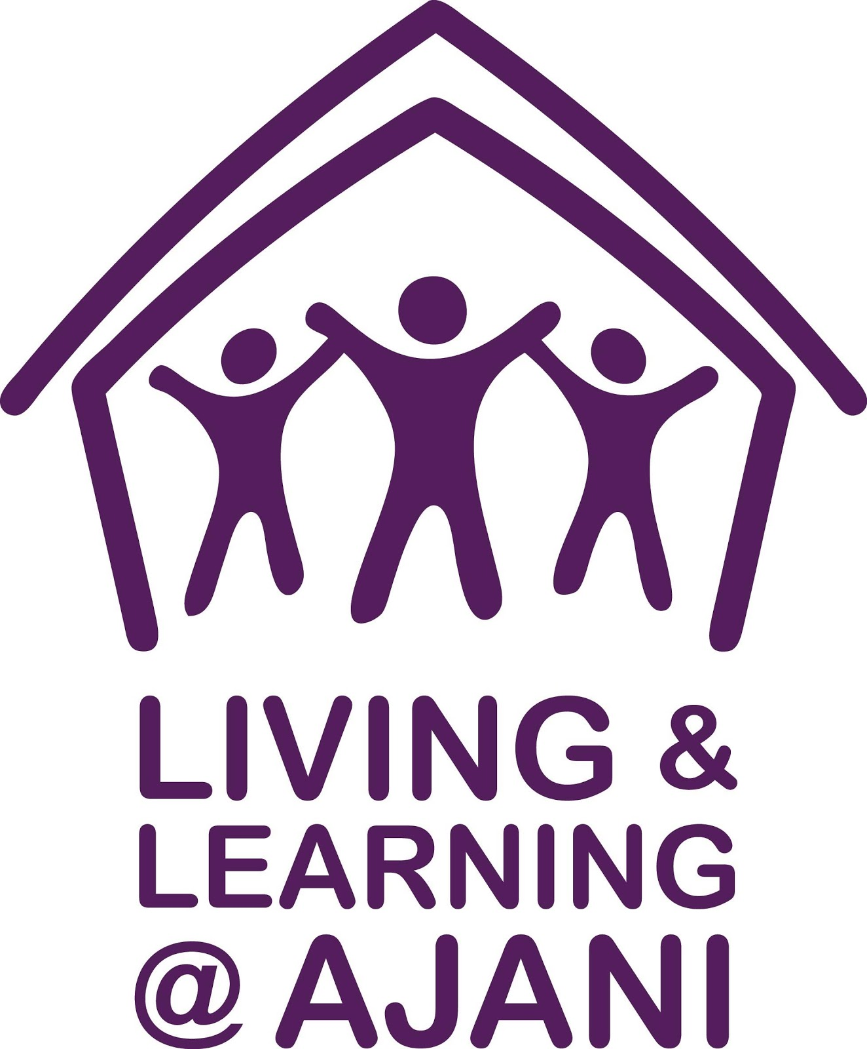

Living & Learning @ Ajani has been working through this social distancing period to bring you these FREE ONLINE courses to help you to ‘stay connected’.

See below for courses available for online learning.

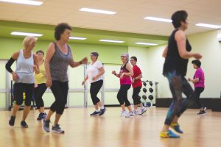 | Gentle Exercise for Over 65’s with Liz  A fun time exercising to music with gentle fitness training, chair based exercises, strengthening, stretching and much more. All exercises can be modified to suit the participant.  Monday 25th May 1.00pm – 1.30pm (30 minutes)  FREE session each week on ZOOM

Online Book Club with Sandra

Join our coordinated Online Book Club, connect with like-minded book lovers and discuss the books we enjoy reading. The first book is Boy Swallows Universe by a wonderful Australian writer, Trent Dalton. Purchase the book (eBook or hard copy) through Kindle, Kobo, Target or
Big W at a cost between $9.00 -$12.00.
First Monday of each month

Monday 1st June from 2.00-3.00pm
FREE session each month on ZOOM

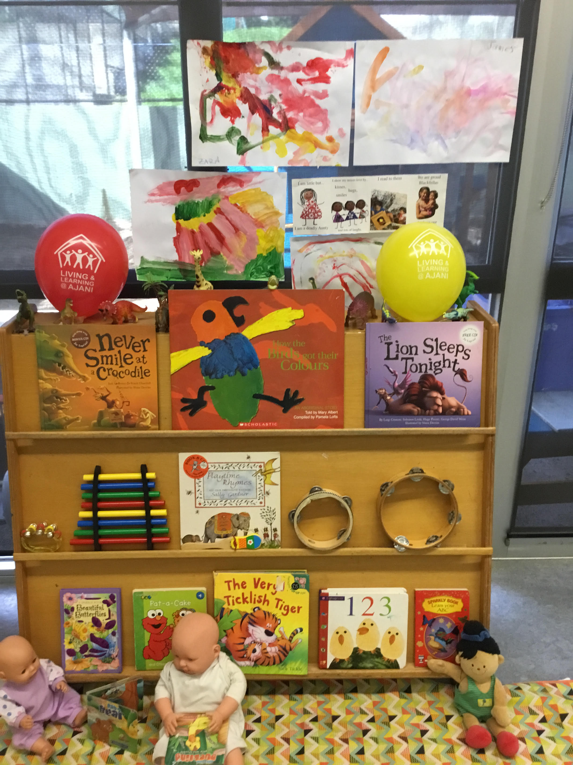 | Children’s story/music with Candy  Let’s journey together in developing your child’s language development with stories, songs, rhymes and movement. All abilities welcome with our Early Learning Hub coordinator Candy.  Thursday 28th May 11.00-11.45am (45 minutes)  FREE session each week on ZOOM

Lego Activity Group with Candy

A fun Lego activity group which caters for all abilities, including those on the spectrum. Candy, our Early Learning Hub Coordinator will guide you through all activities from matching colours to following your special interests or Lego themes.

Thursday 28th May 12.15-12.45pm (30 minutes)
FREE session each week on ZOOM

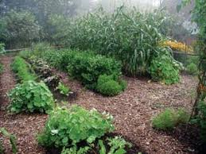 | Earthcraft Home Gardening with Helen & Fil  Working with nature to make gardening easier using simple organic gardening methods. Includes soil improvement using permaculture techniques, no dig gardens, worm farms, companion plants, food forests and tips for living sustainably. Healthy garden, healthy body.  Tuesday 26th May 2.00-3.00pm (1 hour)  FREE session each week on ZOOM

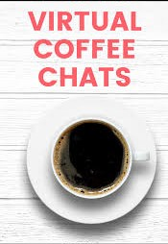 | Coffee & Chat with Sandra  A FREE coordinated online coffee/tea and conversation group where we explore some current topics of interest to everyone. Meet people who are interested in making new friends and listening to other points of view.  Wednesday 27th May from 2.00-3.00pm.  FREE session each week on ZOOM.

Job Skills Career Counselling with Julie Proe, Careers Counsellor

Are you wanting to work through your career options? In one-to-one sessions tailored to your needs, learn skills and apply for jobs. Together we can write your resume and prepare you for interview so that you are successful in gaining the employment you desire.

Thursday 28th May 10.00-11.00am (1 hour)
FREE session each week on ZOOM

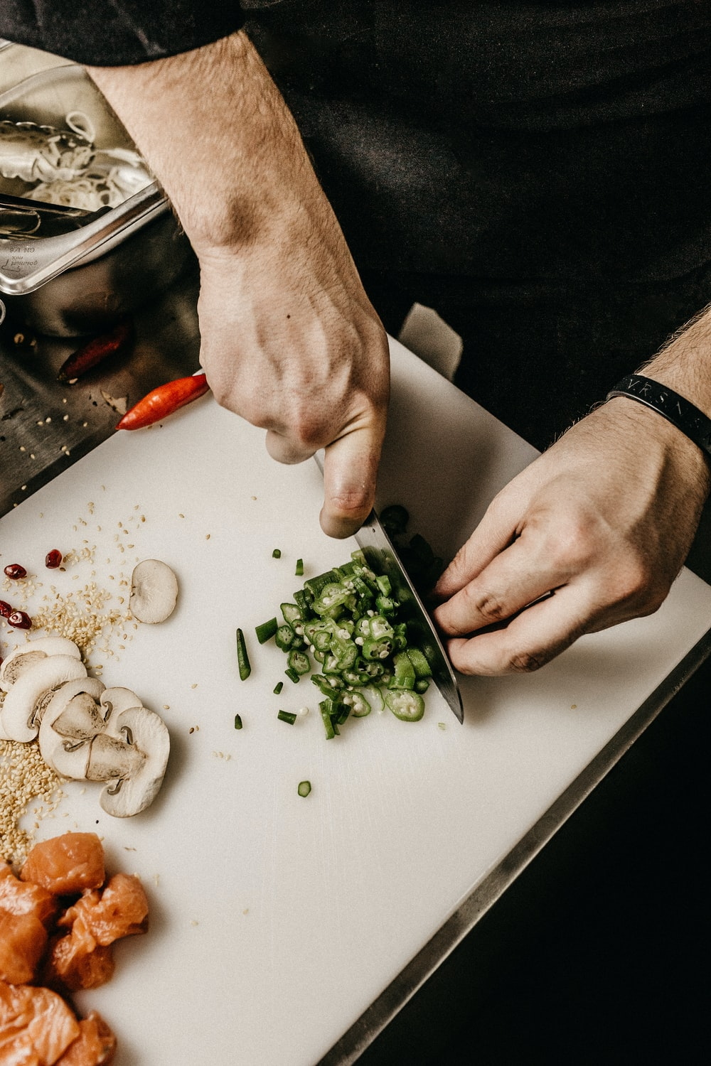 | Cafe & Kitchen Cooking with Liz  Back to basics. Join us for fun and appetising meal preparation for home cooking or a small cafe. Basic but nutritious and tasty meals planned including soups, dips, sweets and more.  Wednesday 27th May 10.00-12.00pm (2 hours)  FREE session each week on ZOOM

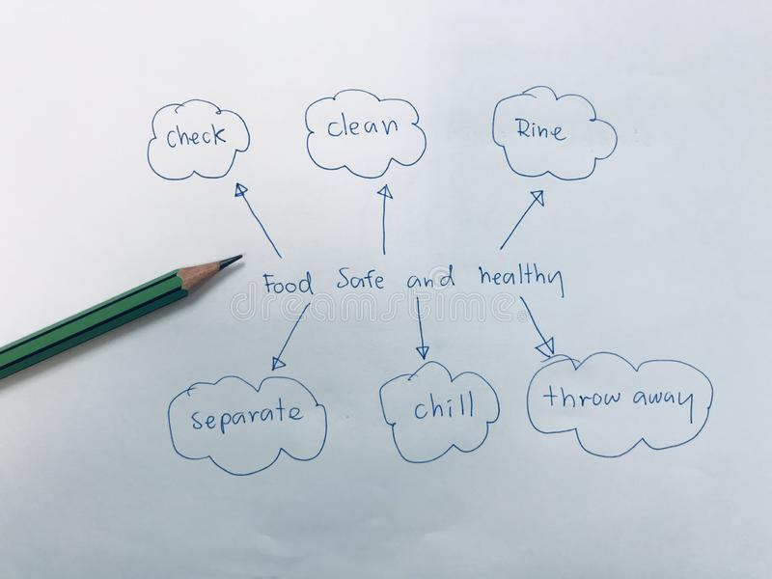 | Safe Food Handling with Hayden  If you are looking to be ready to work in the hospitality industry or handle food, complete your nationally recognised Level 1 Food Safety certificate with us. Course includes 4 online tutorials, 2 open-book assessments and a practical assessment in your kitchen using Zoom.  Wednesdays 12.00-1.00pm (1 hour)  For further details email office@livelearnajani.org.au

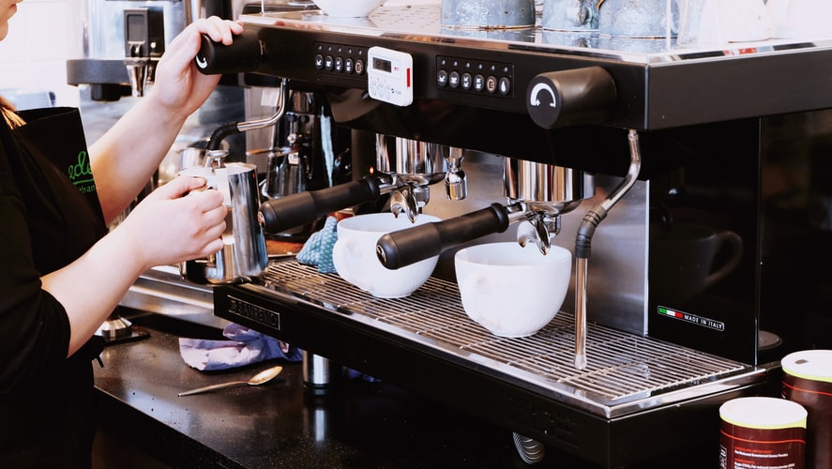
Barista Basics with Hayden

Would you like to be ready to work as a Barista, just have an interest in coffee making or own a machine at home and want to entertain your guests? Our virtual barista class will teach you the basics including milk texturing, coffee making, equipment care and how to make barista quality coffee!

For further details.
office@livelearnajani.org.au

Hatha Yoga with Yvonne

Create cohesion and harmony through balancing stability with mobility, activity and stillness, balancing body-mind relationship. Take the opportunity in our busy, stressful world to join in a Hatha Yoga class suitable for all levels.

Monday 25th May & 1st June 10.00 am – 11.00 am (1 hour)
FREE sessions on Zoom

