Face to Face Exercise Classes January - April 2021 at Living & Learning @ Ajani
Exercise Classes
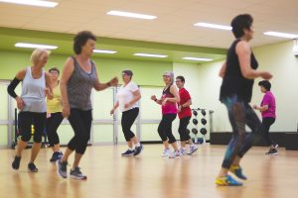 | Balance, Posture & Stretching with Liz  A 1 hour class focussing on balance, correcting posture and lengthy stretches. Suitable for everyone. Bring along a mat.  Wednesday 3rd February 10.00am – 11.00am in the Scout Hall  $90.00 per term (9 weeks) – please book and pay by the term through Humanitix or phone 9850 3687 during office hours to pay over the phone. There is a limit on participants so please book early!

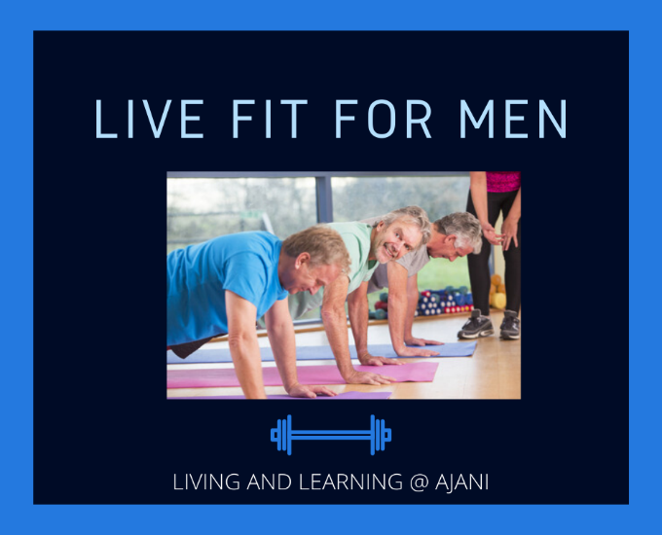 | Live Fit For Men with Benjamin Mason, Physiotherapist  If you would love to do more in the garden, or vary your exercise routine, then join our exercise group for men over 50. Our fun class is led by an experienced Physiotherapist and combines strength, fitness, and balance training for men. Bring along a tennis ball, your own dumbbells and your pack of 3 Therabands if you have them. If not, Ben can supply you with a Theraband pack for $10.00.  Thursday 28th January 8.20am – 9.20am Held in the Ajani Community Hall  $100.00 (10 week term) – please book and pay by the term through Humanitix or phone 9850 3687 during office hours to pay over the phone. There is a limit on participants so please book early!

Ajani Active - Older Adults with Liz
For those who may have participated in our ongoing Ajani Active/Strong People Stay Young sessions or similar programs and/or want to continue to practice and improve or maintain their strength and bone density. Bring along your own dumbbells and a mat.
Wednesday 3rd February 9.00am – 10.00am $90.00 per term (9 weeks) in the Ajani Scout Hall and Friday 5th February 9.00am – 10.00am $80.00 per term (8 weeks) in the Ajani Community Hall. Pay for BOTH days for the term and pay $136.00 – please book and pay by the term through Humanitix or phone 9850 3687 during office hours to pay over the phone. There is a limit on participants so please book early!

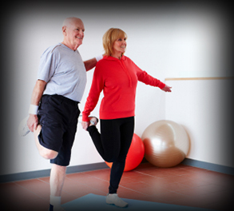 | Standing Strong – A Falls and Balance Class with Ben  Standing Strong is a strength and balance exercise class aimed at preventing falls and boosting mobility, run by Physiotherapist, Ben Mason.  Monday 1st February 1.00pm – 2.00pm  $95.00 per term (8 weeks) in the Scout Hall – please book and pay through Humanitix or phone 9850 3687 during office hours to pay over the phone. There is a limit on participants so please book early!
Hatha Yoga with Yvonne

Create cohesion and harmony through balancing stability with mobility, activity and stillness, balancing body-mind relationship. Take the opportunity in our busy, stressful world to join in a Hatha Yoga class suitable for all levels.

DAYTIME: Tuesday 1st February
9.15am – 10.15am
$85.00 per term (8 weeks)
EVENING: Thursday 7.00pm – 8.00pm
$96.00 per term (9 weeks)
– please book and pay by the term through Humanitix or phone 9850 3687 during office hours to pay over the phone. There is a limit on participants so please book early!

Yoga & Pilates with Karyn

It’s summer! What better time to try something new! Join us for a weekly Yoga & Pilates class that’s friendly, fun and designed to suit individual needs.

Monday 1st February
11.00am – 12.00pm (1 hour)
$85.00 per term (8 weeks)
Note: No class on Labour Day (Monday 8th March)

Circuit Class with Liz

Try out separate exercise stations for cardio, strength and core and designed to provide a full body workout. Bring your own mat and dumbbells.

Tuesday 2nd February
6.15pm – 7.15pm
$90.00 per term (9 weeks) – please book and pay by the term through Humanitix or phone 9850 3687 during office hours to pay over the phone. There is a limit on participants so please book early!

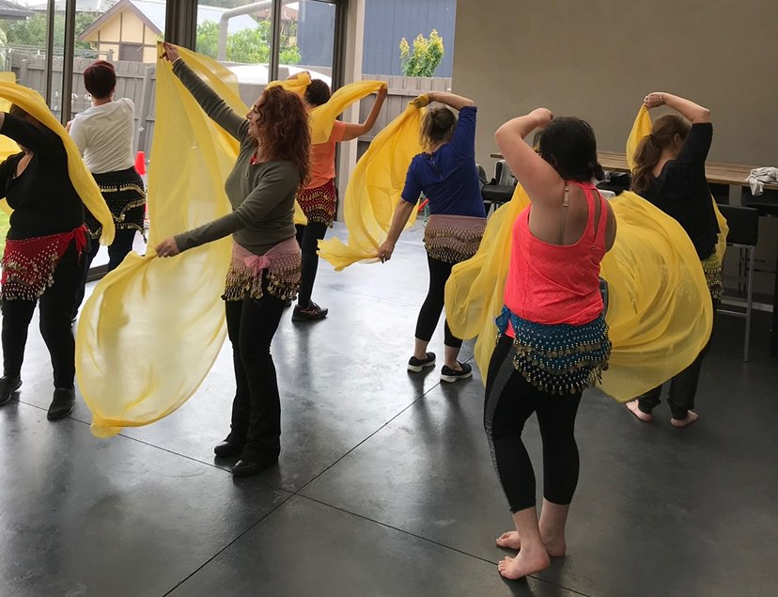 | Belly Dancing with Zabelle  Zabelle is a qualified dance teacher and is offering fun classes covering basic hip and shoulder movements, the recognition of use of abdominal muscles, simple Belly Dance musical rhythms, nuances and poses. Great for all ages!  DAYTIME: Wednesday 3rd February  11.30am-12.30pm  $90.00 per term (9 weeks) held in the Ajani Scout Hall OR  EVENING: Monday 1st February  7.00pm – 8.00pm  $80.00 per term (8 weeks)– please book and pay through Humanitix or phone 9850 3687 during office hours to pay over the phone.  There is a limit on participants so please book early!

Entertainment
West African Drumming with Kate
Explore authentic West African rhythms in a fun and friendly group. African drumming is excellent brain training for all ages as it involves memory, coordination, and the ability to concentrate and synchronise with others. You don’t need a drum to take part – any tabletop, plastic washtub or rounded pot will do. Bring your equipment with you. Explore rhythms with sticks – wooden spoons or pieces of dowel 13mm diameter and approx 40cm in length. This class is suitable for adults and children aged 10 and above. Beginners are very welcome.

Wednesday 3rd February 1.00pm – 2.00pm
$90.00 per term (9 weeks) – held in the Scout Hall. Please book and pay through Humanitix or phone 9850 3687 during office hours to pay over the phone.
There is a limit on participants so please book early!

Children’s Classes
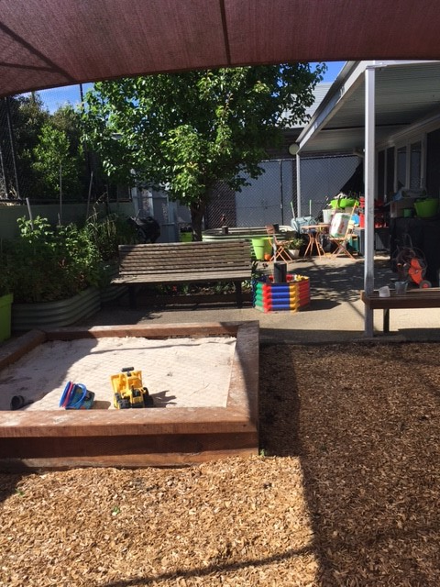 | Children’s Playgroup with Carmen  New indoor/outdoor program with an emphasis on hands-on learning. Enjoy some gardening, art in the garden, updated sandpit, cubby house, story times and indoor fun. Everyone is welcome, especially grandparents!  Wednesday 3rd February  10.00am-12.00am  $170.00 per term (9 weeks) – please book and pay through Humanitix or phone 9850 3687 during office hours to pay over the phone. There is a limit on participants so please book early!

